What Makes Steam Games Successful?
(Capstone Project)

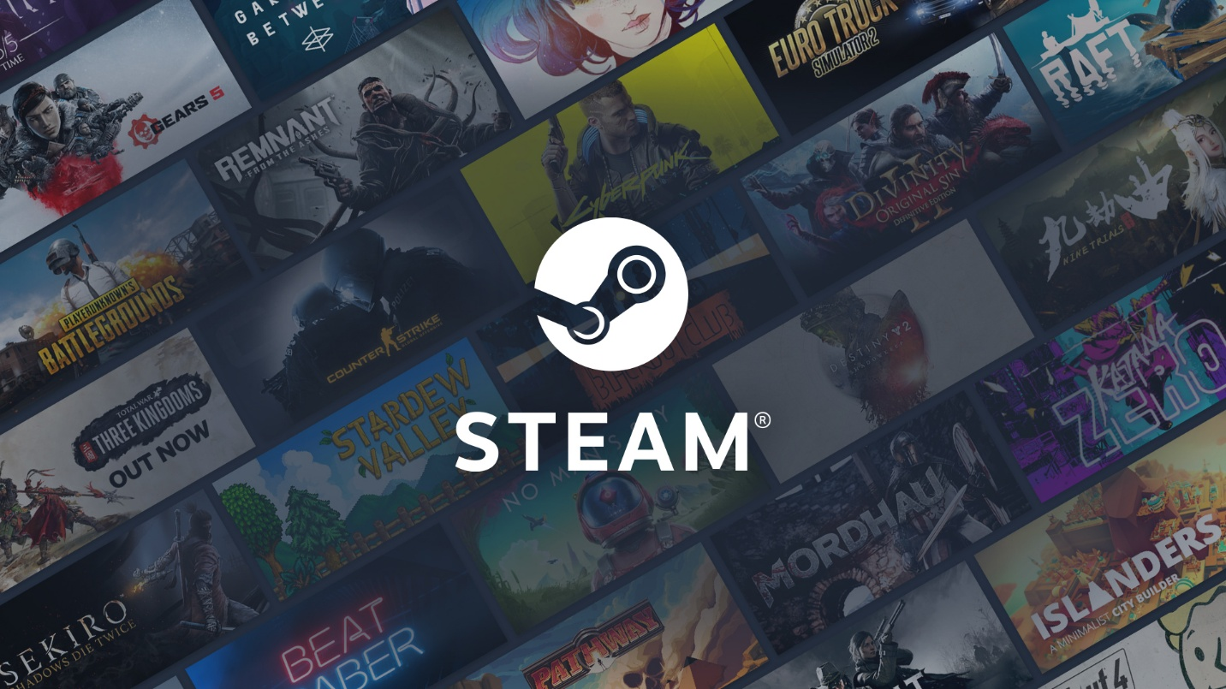

Name: Ahmed Ghassan
Class: DAB-16

Table of Contents
Table of Contents........................................................................................................... 1
Introduction..................................................................................................... 2
Scenario………………............................................................................................. 2
Objectives ......................................................................................................... 3
Aim.................................................................................................................... 3
Target Audience ................................................................................................ 3
Dataset ............................................................................................................. 4
Data Handling.................................................................................................... 6
Limitations ........................................................................................................ 6
Analysis............................................................................................................. 7
Recommendations ...........................................................................................24
References .......................................................................................................24

Capstone Project
(steam)
Introduction:
-What is steam?
The Steam platform is the world's largest digital distribution service for PC games, owned by Valve Corporation. It acts as a massive online storefront where users buy, download, and manage thousands of games, coupled with a comprehensive social ecosystem that includes friend lists, community forums and steam workshop where players can create their customized maps and games mode.
-what this analysis about:
As part of this study, we will examine the core characteristics of Steam games, specifically their primary genre, category, and most used languages, and quantify the relationship between these attributes in achieving high rating.

Scenario:
BoogyGames studio has struggled to achieve strong ratings on Steam, with many of their games receiving negative reviews. Since only 32% of Steam games score above 80%, I was brought in to analyze the platform and identify which combinations of Genre, Category, and supported languages are most likely to achieve ratings above 80% positive reviews.

Objectives:
- What are the most commonly used languages in game?
- How many games are there in each Category and Genre?
- What game Category & Genre are most owned by players?
- What is the Average time played for each genre & category?
- What is total number of Recommendations in each Category & Genre?
- Which game Categories & Genres have maintained above 80% of positive Rating?
- Which developers consistently release games that maintained rating above 80% of positive reviews?
- Which Publisher consistently Publish games that maintained rating above 80% of positive reviews?
- What are the most successful games from leading Developer & Publisher

Aim:
This analysis aims to identify the optimal combination of key factors such as genre, category, and most commonly used language that drive measurable success on the platform and likely to achieve a positive rating.

Target Audience:
Boogygames studio (Robert V. Daly: Studio Head)

Dataset:
Column Name | Definition | Format
appid | Unique Steam Game ID assigned to each game. | Integer
name | Game name | Object/String
release_date | Date the game was officially released. | Object/DateTime
required_age | Minimum age required to play the game. | Integer
price | Listed price of the game in USD. | Float
dlc_count | Number of downloadable content (DLC) packs available for the game. | Integer
detailed_description | Full game description as shown on the Steam store page. | Object/String
about_the_game | Short summary of game content and features. | Object/String
short_description | Brief summary displayed on the product page. | Object/String
reviews | Aggregated or highlighted player review text from Steam. | Object/String
windows | Indicates if the game supports Windows OS. (TRUE/FALSE) | Boolean
mac | Indicates if the game supports macOS. (TRUE/FALSE) | Boolean
linux | Indicates if the game supports Linux OS. (TRUE/FALSE) | Boolean
metacritic | Metacritic score of the game (0–100 scale). | Integer
achievement_count | Number of Steam achievements available. | Integer
recommendations | Total count of Steam user recommendations. | Integer
notes | Additional information or disclaimers provided by the publisher. | Object/String
Suppourted_languages | Languages the game supports is provided. | Object/String
user_score | Steam user score (custom dataset field). | Integer
score_rank | Relative ranking score among games (if available). | Float
positive | Number of positive user reviews. | Integer
negative | Number of negative user reviews. | Integer
estimated_owners | Estimated total owners of the game (approximation based on public APIs). | Integer
average_playtime_forever | Average total playtime per player (minutes). | Integer
average_playtime_two_weeks | Average playtime in the last two weeks per player (minutes). | Integer
median_playtime_forever | Median of total playtime per player. | Integer
median_playtime_two_weeks | Median of playtime in last two weeks. | Integer
discount | Current discount percentage (0 = none). | Integer
peak_ccu | Peak concurrent users (maximum number of simultaneous players). | Integer
tags | Dictionary-like field indicating most relevant genre/category tags. | List/ string
pct_pos_total | Percentage of total positive reviews. | Integer
num_reviews | Total number of all-time reviews (positive + negative). | Integer
pct_pos_recent | Percentage of recent reviews that are positive. | Integer
num_reviews_recent | Total number of reviews received recently. | Integer
genres | List of genres assigned to the game (e.g., Action, RPG, Adventure). | String
categories | List of categories or game modes (e.g., Single-player, Multiplayer). | String
developers | Name(s) of the game developer(s). | String
publishers | Name(s) of the game publisher(s). | String

Data handling:
Please refer to Jupyter Notebook.
Limitation:
- The dataset does not include any information about game revenue, which is an important a key measure of success.
- The dataset is not time-based and only provides all-time data, making it difficult to identify trends such as the most popular genres or categories in a specific year.
Analysis:
Supported languages:
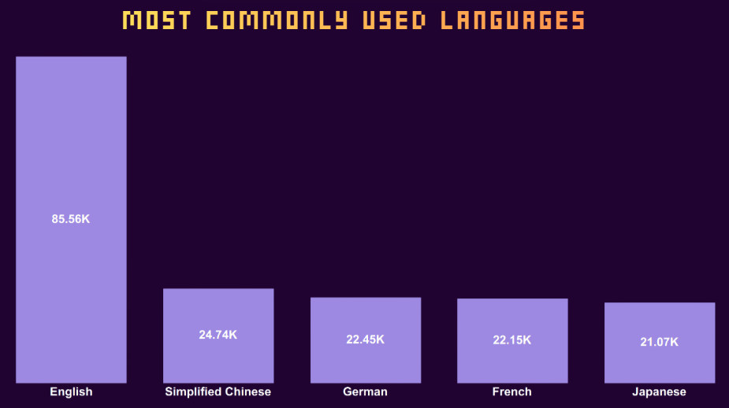

The visual shows the top 5 supported languages in Steam games. English is the dominant language by far as it’s a universal language, supported in 85.56K games. Simplified Chinese is the highest-ranking secondary market with 24.74K supported games which is expected as Simplified Chinese is the Most spoken language , closely followed by the major European languages, German (22.45K) and French (22.15K), with Japanese rounding out the top five at 21.07K. Most of steam platform games is English language supported followed by chines as second supported language which give an insight to focus on these two supported language to access the two biggest players community.

Reviews Category:
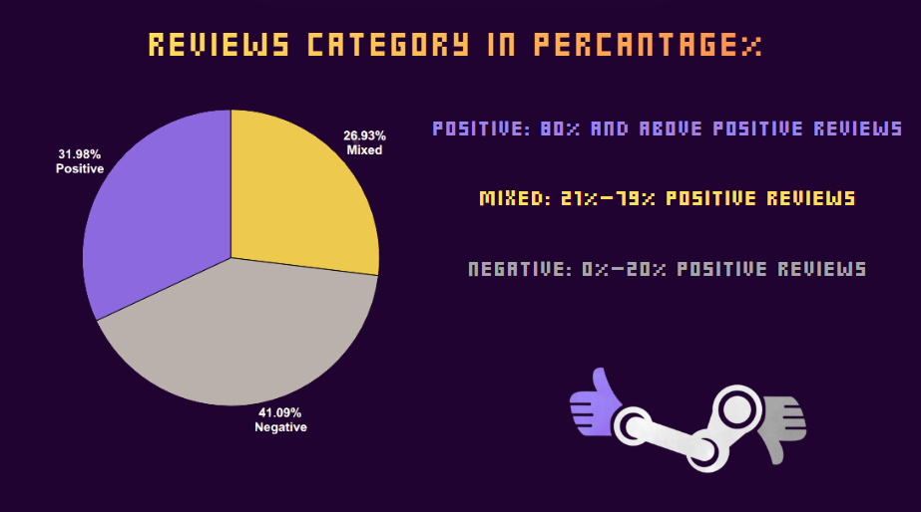

The visual shows the distribution of game reviews categorized by Total positive reviews, revealing that the highest percentage of games falls into the Negative reviews category at 41.09% which represent that almost half of steam games are getting negative reviews. The Positive review category is second at 31.98%, with the Mixed category accounting for the remaining 26.93%.
These proportions were determined by classifying games according to the percentage of positive reviews:
IF statement was used for this calculation (calculation field)
- Positive: games with 80% or more positive reviews,
- Mixed: games with 21%–79% positive reviews, and
- Negative: games with less than 20% positive reviews.

Category:
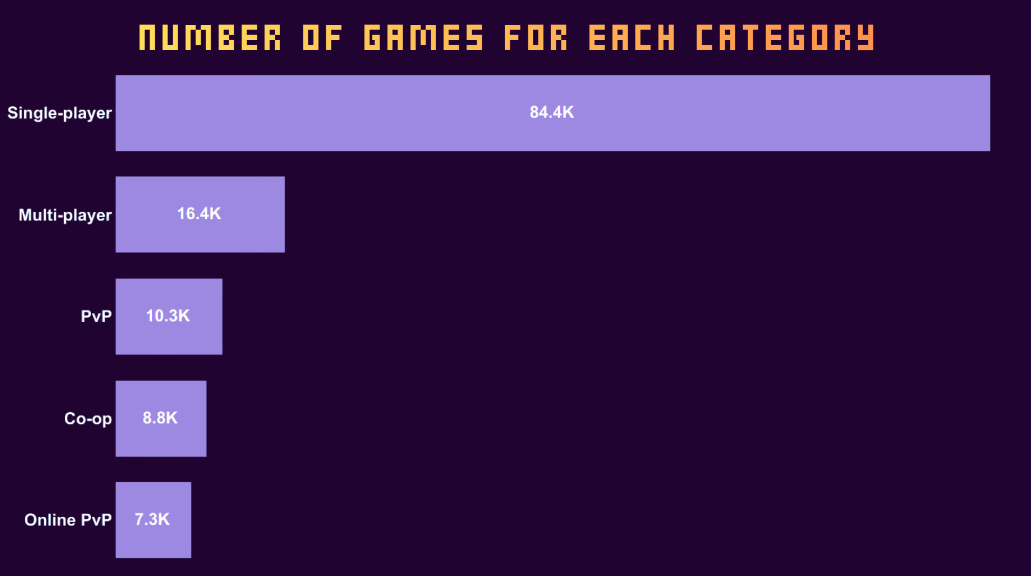

The visual shows the total number of games for each category, highlighting the extreme dominance of single-player content. Single-player games lead massively with 84.4K games. Multi-player is the second largest category, but significantly smaller at 16.4K games. The remaining categories are PvP with 10.3K, Co-op 8.8K, and Online PvP 7.3K are all tightly grouped at the bottom, confirming that the vast majority of game released on steam platform are built around the core single-player games.

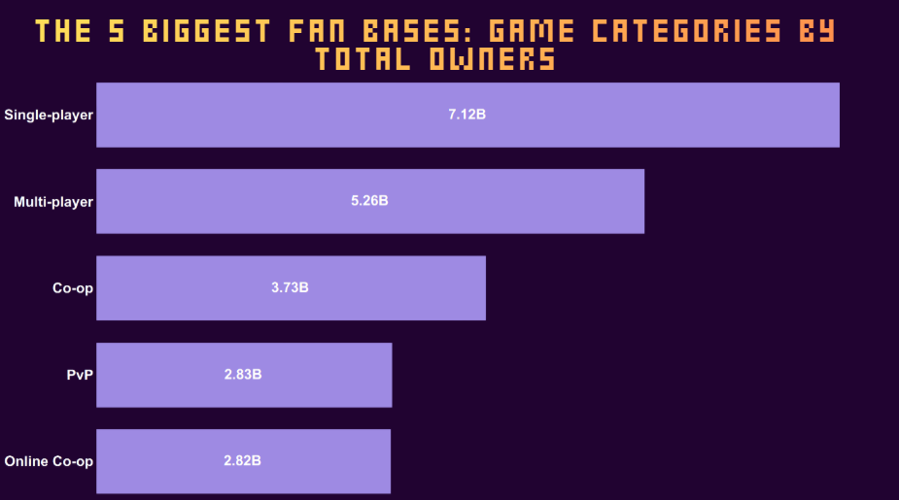

The visual shows the total estimated number of owners across different game categories, clearly demonstrating that single-player experiences dominate the market with 7.12 Billion estimated owners. Multi-player games are the second largest category with 5.26 Billion owners. Followed by Co-op at 3.73 Billion, and PvP 2.83 Billion and Online Co-op 2.82 Billion. This visual give an insight that single-player and multi-player are the most dominant Category as large portion of players owns games with these two categories.
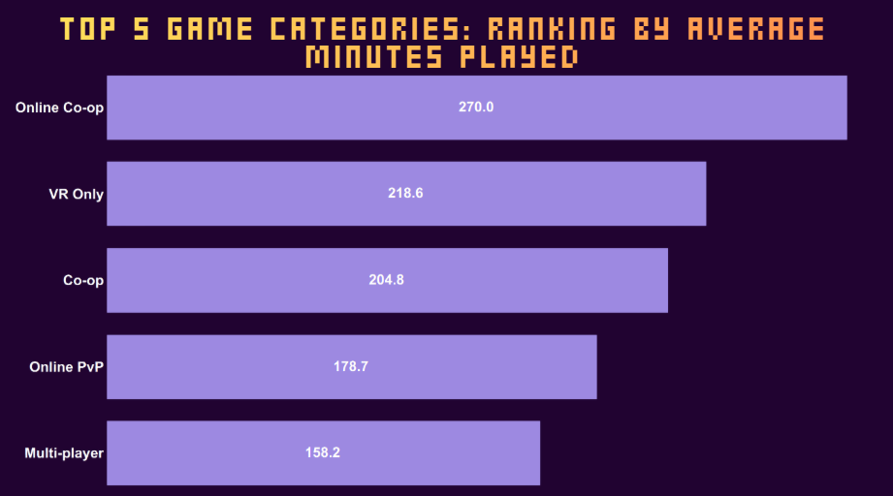

The visual shows the average playtime in minutes for the top genres, online – Co – op games dominate the list with an average playtime of 270 minutes, followed by Online Co-op at 270 minutes. VR Only games surprisingly rank third with 218.6 minutes, exceeding traditional Co-op 204.8 minutes and Online PvP 178.7 minutes. This gives an insight that players have longer session in Online Co - op games.

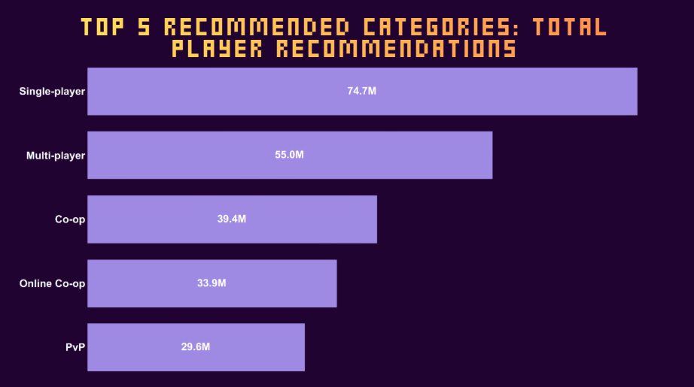

The visual ranks game categories by the total number of player recommendations (in millions), demonstrating that single-player and multi-player game category is highly recommended by player. Single-player games lead significantly with 74.7M recommendations. Multi-player is the second largest at 55.0M, followed by Co-op (39.4M) and Online Co-op (33.9M). Followed by PvP with 29.6M.
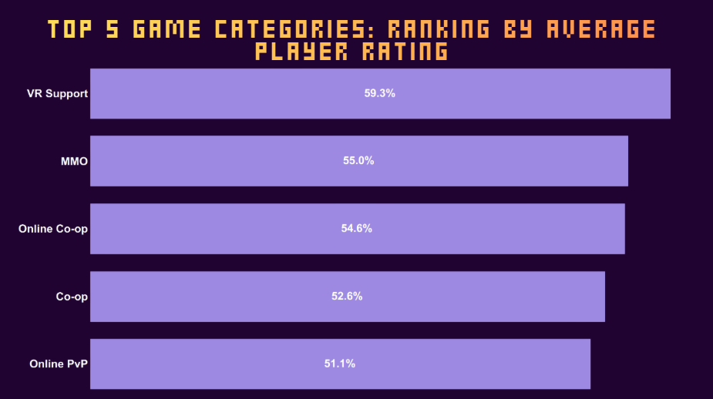

The visual ranks the top 5 categories by their average player rating percentage. VR Support leads the list significantly with an average rating of 59.3%, indicating number of positive reviewed VR games is larger than negative reviewed VR games. MMOs follow at 55.0%, ahead of Online Co-op 54.6%, Co-op 52.6%, and Online PvP 51.1%.
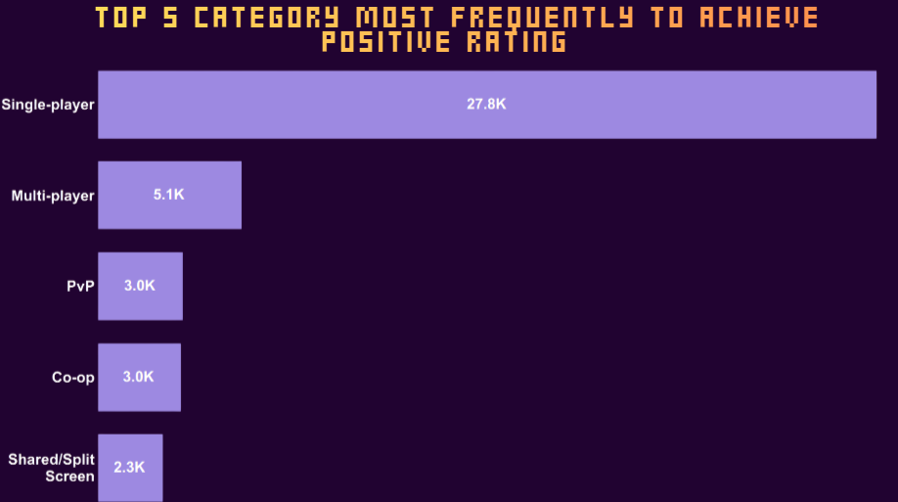

The visual shows which game categories most frequently achieve a high positive rating (80% or more), with Single-player dominating the list at 27.8K high-rated games. The remaining categories multi-player 5.1K, PvP 3.0K, Co-op 3.0K, and Shared/Split Screen 2.3K. This visual shows that single- player games is most likely to achieve high positive rating. As its most frequently to achieve positive rating by big difference compared to other top category.

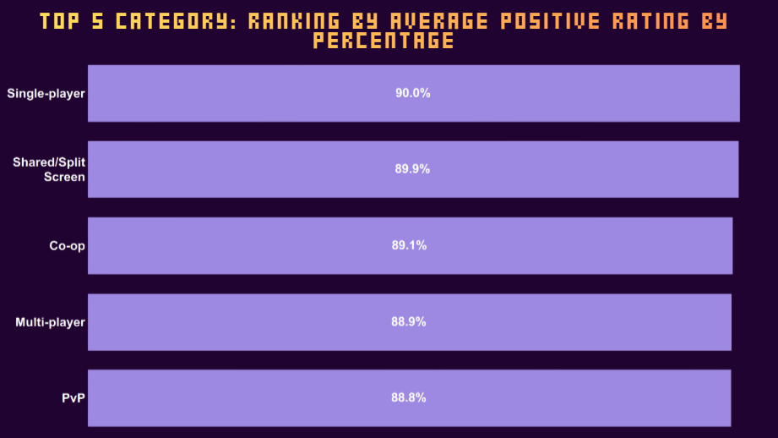

The visual shows the proportion of games within each category that achieve an 80%+ positive rating, demonstrating that all top categories consistently rate extremely high, clustered tightly between 88.8% and 90.0%. Single-player games lead narrowly at 90.0%, followed by Shared/Split Screen 89.9% and Co-op 89.1%. Followed by multi-player 88.9% and PvP 88.8%. The extremely narrow range of ratings all clustered tightly around 90% to 88% indicates that successful games across these diverse category are equally capable of earning high praise from players , especially single-player game as they appeared in multiple visual as top one which shows that many player prefer single-player games over other category.

Genre:
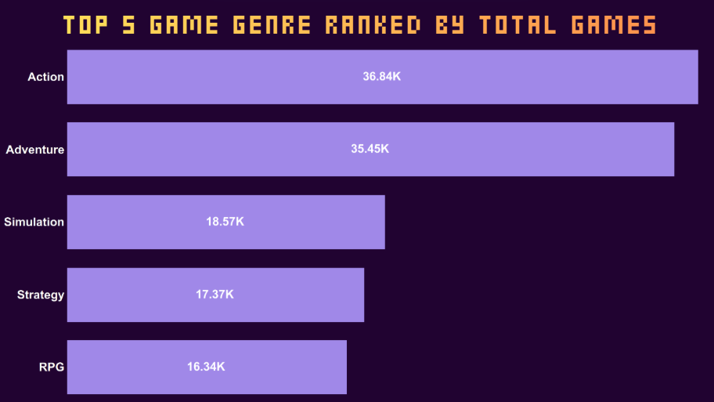

The visual shows the top 5 total number games in each genre, demonstrating the massive supply of Action and Adventure genre. Action games is placed in top one at 36.84K, slightly ahead of Adventure with 36.84K games and simulation with 18.57K games. Followed by strategy genre with 17.37k games.
RPG genre rounds out the top five with 16.34K games.
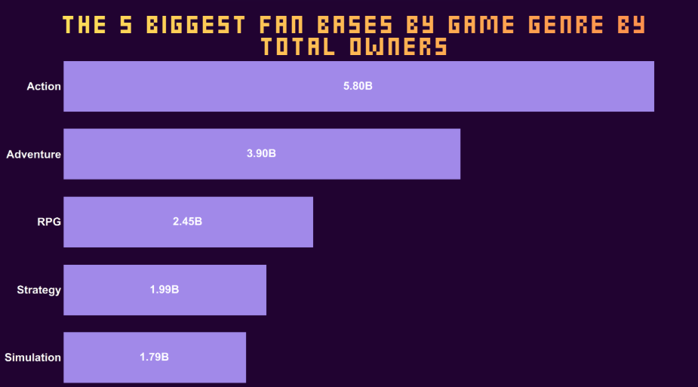

These visual displays the total estimated number of owners for the top five Steam game genres. The Action genre dominates with 5.8 Billion owners, followed by Adventure at 3.90 Billion, and RPG at 2.45 Billion. The Strategy and simulation categories complete the top five with 1.99 Billion and 1.79 Billion owners. This visuals provide an insight that Action games are the most owned genre among players, leading all other categories.

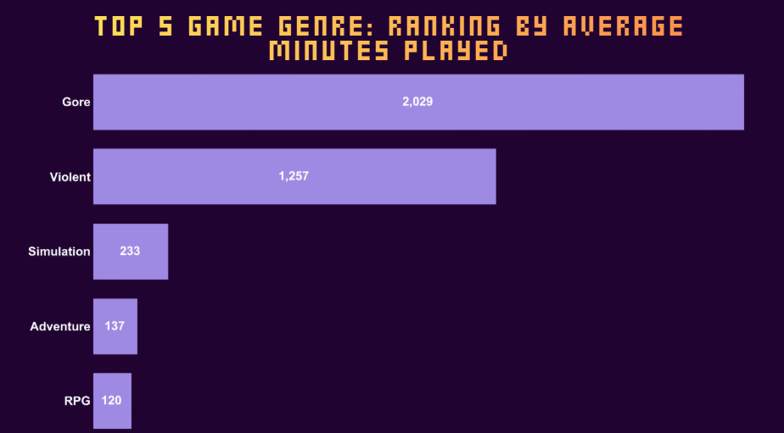

The visual shows the average playtime in minutes for the top genres, demonstrating a massive lean toward the most extreme categories. The Gore genre dominates with an average playtime of 2,029 minutes, followed closely by the Violent genre at 1,257 minutes. Followed by the more traditional genres like Simulation 233 minutes, Adventure 137 minutes, and RPG 120 minutes. This gives an insight that players have longer session in more extreme or intense content.
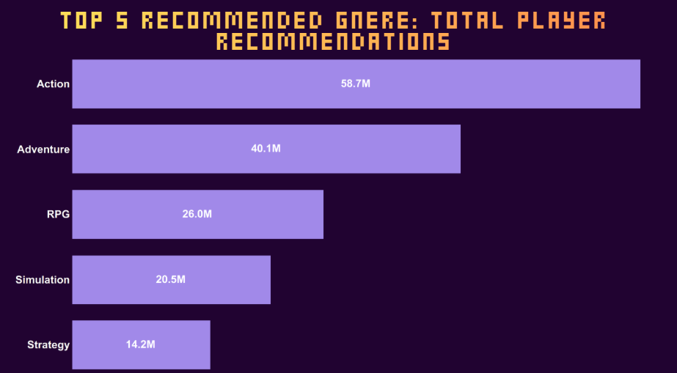

The visual ranks the top game genres by the total number of player recommendations (in millions). Action games lead significantly with 58.7M recommendations. Followed by Adventure with 40.1M total recommendations .Followed by RPG 26.0M and Simulation with 20.5M total recommendations. Followed by strategy with 14.2M total recommendation. Findings reflects that Action games are the most recommended game genre by players, followed closely by Adventure games.
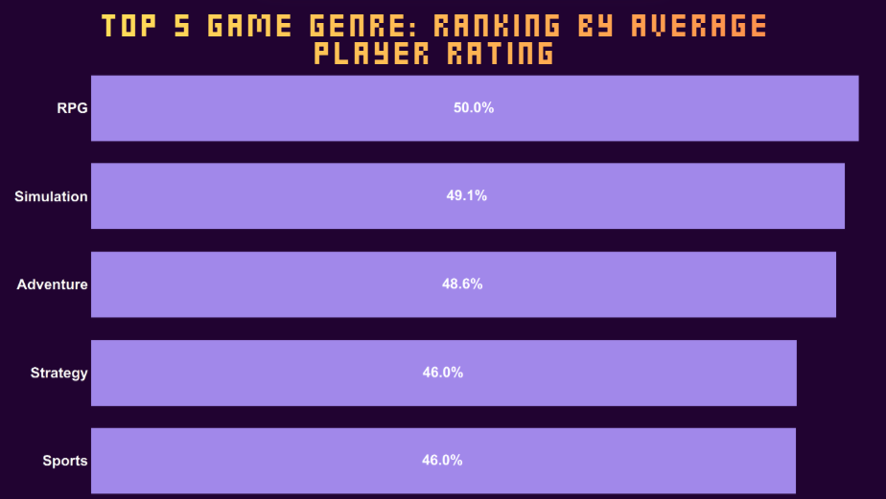

The visual ranks the top genres by their average player rating in percentage. RPG games lead the list narrowly with a 50.0% average rating, followed closely by Simulation 49.1% and Adventure 48.6%. Strategy and Sports round out the top five with tied player rating of 46.0%. Findings shows that RPG(role play game) leads the list slightly only with an average rating of 50.0%, indicating number of positive reviews equal to negative reviews.

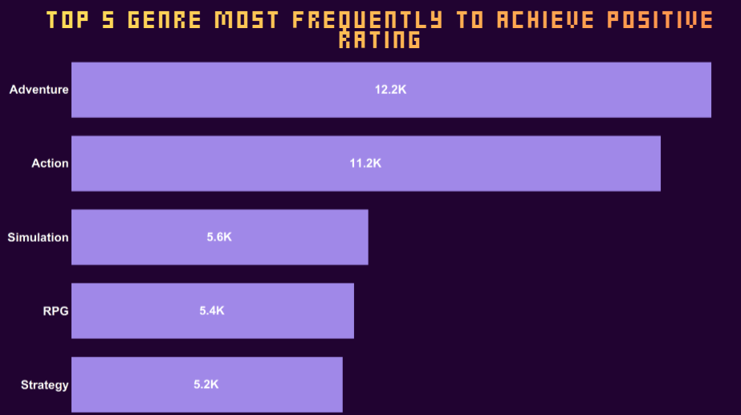

The chart shows which game genres most frequently achieve a high positive rating (80% or more) and reveals that the Adventure genre is the most successful at this, with 12.2K high-rated games. closely followed by Action at 11.2K. Followed by Simulation, RPG, and Strategy genres form a tighter cluster at the bottom, with 5.6K, 5.4K, and 5.2K .This visual gives an insight that Adventure and Action game is the most frequent genre to achieve high positive rating.

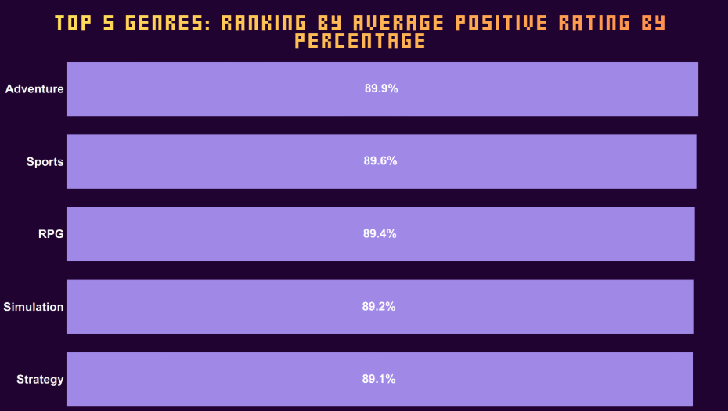

The visual ranks the top genres by their average total positive rating in percentage (80% or more),it shows that all top genres achieve a near-identical high level of positive players review. Adventure leads the list slightly with an average positive rating of 89.9%, followed closely by Sports at 89.6%, and RPG at 89.4%. The Simulation 89.2% and Strategy 89.1% genres complete the top five. The extremely narrow range of ratings all clustered tightly around 89% indicates that successful games across these diverse genres are equally capable of earning high praise from players.

Developers:
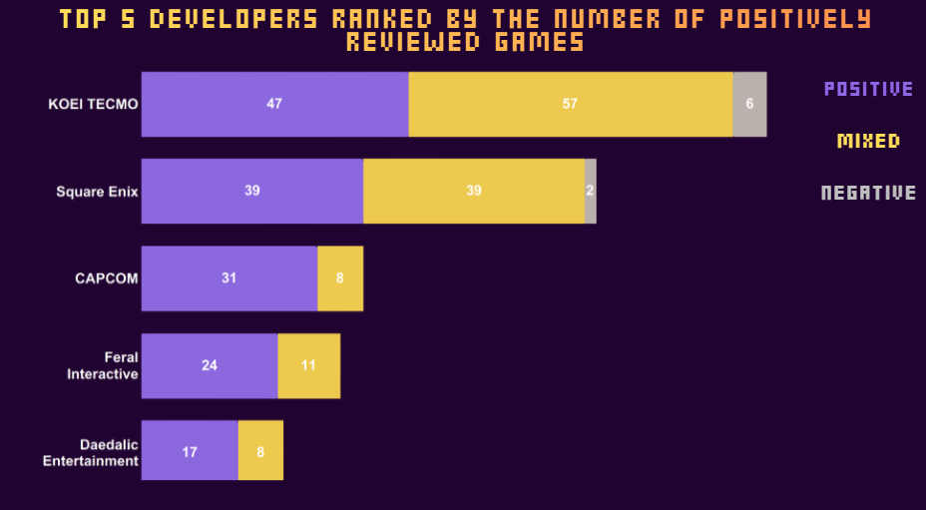

The visual ranks the top five developers based on the number of positively reviewed games they have released, while also breaking down the distribution to three reviews segments (Positive, Mixed, Negative). KOEI TECMO leads in overall volume of reviewed games, achieving 47 Positive and 57 Mixed titles, plus 6 Negative. Square Enix follows with 39 Positive and 39 Mixed titles. CAPCOM is third with 31 Positive and 8 Mixed games, followed by Feral Interactive 24 Positive, 11 Mixed and Daedalic Entertainment 17 Positive, 8 Mixed. This indicates that while KOEI TECMO produces the highest volume of reviewed games but with high number of mixed reviews while Square Enix studio is more balanced split between Positive and Mixed sentiment.

Publisher:
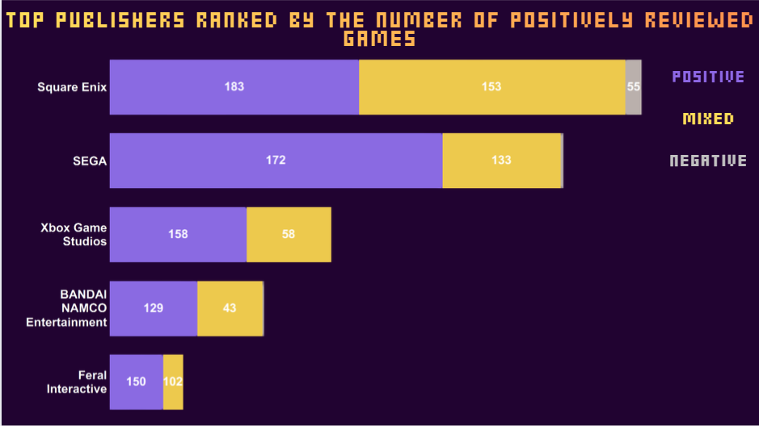

The visual ranks the top five publishers by the number of positively reviewed games they have released, while also breaking down the distribution to three reviews segments (Positive, Mixed, Negative) . Square Enix leads with 183 Positive but also has the largest volume of Mixed 153 and Negative 55 reviews overall. SEGA follows closely with 172 Positive and 133 Mixed games. Xbox Game Studios is third with 158 Positive and 58 Mixed titles. BANDAI NAMCO Entertainment 129 Positive, 43 Mixed and Feral Interactive 150 Positive, 102 Mixed round out the top five, demonstrating that while Square Enix generates the highest volume of positive hits, their output also receives the most mixed and negative reviews.
Recommendation:
- Focus on single-player as game Category and Action as a game genre. they have the most owners and are most likely to reach above 80% of total positive reviews.
- Include English and Simplified Chinese to access the largest communities of players on Steam.
- Consider adding VR Support as this category show strong average ratings and long playtime.
- Work with trusted publishers (like Square Enix or SEGA) to improve visibility and increase player trust.

References:
- https://store.steampowered.com/
- Steam Games Dataset 2025

